Parish Councillors are duly summoned to attend a Briercliffe with Extwistle Annual Parish Council meeting to be held Thursday January 23rd 2025 at 6.30pm at the Community Centre, Jubilee Street

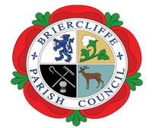

Members of the public are invited to attend.

BRIERCLIFFE WITH EXTWISTLE PARISH COUNCIL

PARISH COUNCIL MEETING

Thursday January 23rd 2025 at 6.30pm

Welcome

1. Announcements

a. Recording of meetings

2. Apologies for absence and reasons given

3. Declarations of Disclosable Pecuniary Interests

4. To fulfil the Parish Council Obligations under Schedule 7 for Audit.

 [www.briercliffe-pc.gov.uk](http://www.briercliffe-pc.gov.uk/)